New Mexico Pharmacists Prescriptive Authority for Contraception
Moodle
Q
UICK STEPS

- Access Moodle course at: https://hscmoodle.health.unm.edu/course/view.php?id=535
- Log in or create an account [Confirm account if needed]
- Enter enrollment key to enroll [birthcontrol]
- Begin course

A
CCESSING MOODLE

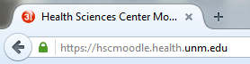
Type https://hscmoodle.health.unm.edu/ into the Address bar or click on the link. Don’t forget to bookmark it!

N
EW ACCOUNT USER

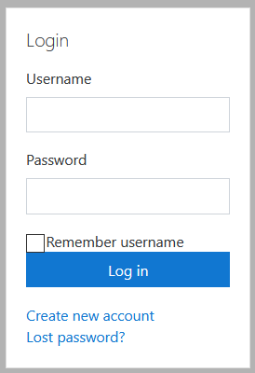
- On the right hand side of the page select 'create new account'.
- Fill in the required fields (we suggest your first initial plus last name for a username e.g. gwashington)
  - Note that your first and surname (Last name) you enter is what will print on any certificates awarded.
- Click “create my new account”
- Click the link in the confirmation email to confirm your account [required].
  - If no email is received with-in 30 minutes check your junk folder.
  - If no email is present contact HSC-NEOTechSupport@salud.unm.edu for us to confirm for you.
- Don’t forget to write down your username and password

P
REVIOUS ACCOUNT USER

If you have an existing account, use this information to log-in.
Forgotten Username or Password
Do one of two things depending on your needs
- Active email account: Request your account information by clicking on the Lost Password link. You will need to know your username OR email account information.
- Inactive/wrong email account: If you requested a rest and never received an email OR it is no longer in use contact NEO directly at HSC-NEOTechSupport@salud.unm.edu to request an update. We will update your account information and assign a temporary password.

E
NROLL IN COURSE

There are two ways to access your courses
- Direct link: https://hscmoodle.health.unm.edu/course/view.php?id=535
- Find the Course in the course Categories as follows:

Pharmacy >> Pharmacists >> NMhA Prescriptive Authority for Hormonal Contraception (Pharmacists)

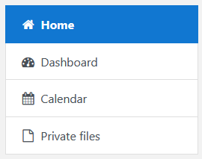
- After you’ve found your course, enter the enrollment key (You will only need to enter this key ONE time per year).
- Once enrolled you can access the “Dashboard” to see a list of enrolled courses
Located on the left side of the main page; can also found under your profile

T
ECHNICAL SUPPORT

If you run into any technical problems email: HSC-NEOTechSupport@salud.unm.edu with your name, course title, and any specifics on your problem.

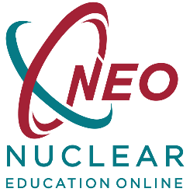
Enrollment Key = birthcontrol

