New Mexico Pharmacists Prescriptive Authority for Contraception

A
CCESSING MOODLE

With your browser open type in: https://hscmoodle.health.unm.edu/ into the Address space located on your toolbar in your browser widow OR click on the link above. Direct link: https://hscmoodle.health.unm.edu/course/index.php?categoryid=9 Don’t forget to bookmark it!

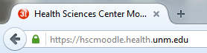

N
EW ACCOUNT USER

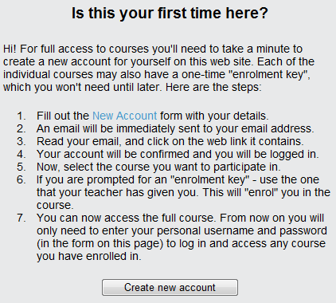
- You must create an account. On the right hand side of the page select 'create new account'.
- Fill in the required fields (we suggest your first initial plus last name for a username e.g. gwashington)
  - Note that first and surname (Last name) you enter is what will print on any certificates or records.
- Click “create my new account”
- The system will send you an email to confirm your account immediately. You must confirm your account to gain access.
- Click the link in the email (or copy and paste it into the address window in your browser) to confirm your account. If you do not receive a confirmation email with-in 30 minutes contact HSC-NEOTechSupport@salud.unm.edu for manual confirmation.

Don’t forget to write down your username and password

P
REVIOUS ACCOUNT USER
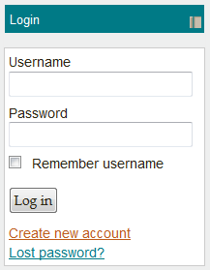
If you have already created an account or we previously created one for you, please use this information to log-in. Otherwise see below for other options.
Forgotten Username or Password
You can do one of two things depending on your situation
- Active email account: Request your account information by clicking on the “Lost Password?” link. You will need to know your username and active email information.
- Inactive email account: If you are not sure what email is on your account OR it is no longer in use contact NEO directly at HSC-NEOTechSupport@salud.unm.edu to request account information. A temporary password will be assigned to you. Please update account information with current information after logging in.

U
PDATE PROFILE INFORMATION
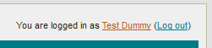
Need to update your account with new information such as email, location, username etc.? Follow the steps outlined to update your profile.
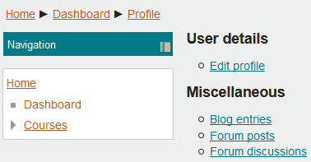
- Once logged in you can click on your account profile located at the top right corner of the screen. You will see a message that says "You are logged in as [name here]"
- Click on your name. You will then see your account info.
- Click on the Edit profile link
- Update any of the fields needed (email, location, username etc.)
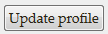
- Don't forget to save the changes by clicking on the Update Profile button located on the bottom of the screen

C
OURSE ACCESS

Now that you have logged into your account you can access the course!
- On the right side of the page, under “Course Search,” search for “contraception”

Course Search

Search coursesGo

New Mexico Pharmacists Prescriptive Authority for Hormonal Contraception (Pharmacists)

Click on the “New Mexico Prescriptive Authority for Hormonal Contraction (Pharmacists)” link. Enter the enrollment key ‘birthcontrol’ and hit “Enroll me” to enroll in the course.

Enrollment Options:
New Mexico Pharmacists Prescriptive Authority for Hormonal Contraception (Pharmacists)

T
ECHNICAL SUPPORT

If you run into any technical problems email: HSC-NEOTechSupport@salud.unm.edu with your name, course title, phone number, and any specifics on your problem.
If you have a question about the content please email faculty at: HSC-AskNEOFaculty@salud.unm.edu

